 | MINISTRY OF EDUCATION AND TRAINING

FPT UNIVERSITY
Capstone Project Document
HOTEL WEBSITE
Project Team
Group members | Nguyen Viet Hung | SE03577
Group members | Vu Tran Hoang | SE03931
Group members | Dang Cong Son | SE03564
Group members | Dang Duc Manh | SE03539
Group members | Tran Ba Quyen | SE02724
Supervisor | Mr.Phan Truong Lam
Capstone Project Code | HOWE
-Ha Noi May 8th, 2017-

Contents
1 Introduction Project(Report 01) 4
1.1 PURPOSE 目的 4
1.2 PROJECT INFORMATION プロジェクトの情報 4
1.3 PROJECT MEMBERS 4
1.4 PROPOSAL 提案 5
1.4.1 Problem 問題 5
1.4.2 Solution 解法 5
1.4.3 Idea アイディア 5
1.5 LITERATURE REVIEW OF EXISTING WEBSITES 5
1.5.1 Kim Lien Hotel 6
1.5.2 Hilton Hotel 6
1.5.3 Comparison 7
2 Software Project Management Plan (SPMP – Report 02) 8
2.1 Problem Definition 8
2.1.1 Name of this CapStone Project 8
2.1.2 Problem Abstract 8
2.2 Project organization 8
2.2.1 Software Process Model 8
2.2.2 Roles and Responsibilities 9
2.2.3 Tools and Techniques 11
2.3 Project management plan 12
2.4 Coding Convention 12
2.5 MEETING MINUTES 打ち合わせ議事録 15
2.6 PROJECT MILLSTONES プロジェクトマイルストーン 15
2.7 RESOURCES リソース 16
2.7.1 Human resource 人的リソース 16
2.7.2 Non-human resource 機器やツール 16
2.8 RISK MANAGEMENT リスク管理 16
2.9 COMMUNICATION MANAGEMENT コミュニケーション管理 18
2.9.1 Communication between Team Members チームメンバーの間のコミュニケーション 18
2.9.2 Communication with Supervisor 指導教員とコミュニケーション 18
2.10 CONFIGURATION MANAGEMENT PROCESS コンフィグレーション管理のプロセス 18
2.10.1 CI Identification and Naming Convention 構成アイテムと命名規則 18
2.10.2 Project Infrastructure プロジェクトインフラストラクチャ 20
2.10.3 Directory structure ディレクトリ構造 21
3 Software Requirements Specifications (SRS – Report 03) 22
3.1 User Requirement Specification 22
3.2 System Requirement Specification (Specific Requirements) 22
3.2.1 Business Rule 22
3.2.2 Functional Requirement 22
3.2.3 Non – Functional Requirement 63
3.3 Entity Relationship Diagram 64
3.4 Other material (if any) 64
4 Software Design Description (SDD – Report 04) 65
4.1 Design Overview 65
4.2 System Architectural Design 65
4.2.1 Choice of System Architecture 65
4.2.2 Discussion of Alternative Designs 65
4.2.3 Description of System Interface 65
4.3 Component Diagram 65
4.4 Detailed Description of Components 65
4.4.1 CRC Cards (Class-Responsibility-Collaborators) 65
4.5 Sequence Diagram 65
4.6 User Interface Design 65
4.7 Database Design or Data Structures 65
4.8 Other material (if any) 65

Table 1.1 – Project Information 7
Figure 1.1 – Iterative software process model 11
Table 2.1 – Project Team 14
Figure 1.2 – Meeting Minutes 18
Table 2.2 – Project Milestones 19
Table 2.3 – Risk Management 20
Table 2.4 – Naming Convetion 23
Table 2.5 – Tools needed for project 23
Table 2.6 – Directory structure 24
Table 3.1 – Bussiness Rule 25
Figure 1.3 – Guest Use Case Diagram 26
Figure 1.4 – Receptionist Use Case Diagram 32
Figure 1.5 – Manager Use Case Diagram 43
Figure 1.6 – Accountant Use Case Diagram 61

Acronym | Definition | Note
JFS | Hotel Website | Project’s name
SRS | Software Requirement Specifications
CI | Configuration Item
CM | Configuration Management
Admin | Administrator
Member | Employer and Job Seeker
PM | Project Manager
PTL | Project Technical Leader
CRC | Class-Responsibility-Collaborators
AT | Acceptance Test
IT | Integration Test
KLOC | 1000 lines of code
PM | Project Manager
PTL | Project Technical Leader
PT/TT | Program Test/ Total Test
QA | Quality Assurance
UT | Unit Test
PC | Personal Computer
UI | User Interface

Introduction Project(Report 01)

PURPOSE 目的
Tài liệu này cung cấp cái nhìn tổng quan về nhóm phát triển dự án, bao gồm các thông tin về dự án, đưa ra ý tưởng ban đầu đánh giá tìm hiểu các vấn đề và giải pháp của dự án. Đồng thời nghiên cứu đánh gia các hệ thống tương tự đang được sử dụng hiện nay
This chapter provides an overview of Hotel Website, it includes background information and literature review of existing system.

PROJECT INFORMATION プロジェクトの情報
Project name: | Hotel Website
Project code: | HOWE
Project type: | Website
Project category: | New development
Business type: | Business
Project manager: | Nguyen Viet Hung
Timeline: | May 8th,2017 - Aug 26th, 2017
Table 1.1 – Project Information

PROJECT MEMBERS
- Supervisor:
Full name | E-mail | Title
Phan Truong Lam | Lampt2@fe.edu.vn | Lecturer

- Team members:

Full name | Roll number | E-mail | Phone | Position
Nguyen Viet Hung | SE03577 | hungnvse03577@fpt.edu.vn | 01648172064 | Leader
Vu Tran Hoang | SE03931 | hoangvtse03931@fpt.edu.vn | 096.296.2174 | Member
Dang Cong Son | SE03564 | sondcse03564@fpt.edu.vn | 0129 639 6358 | Member
Dang Duc Manh | SE03539 | manhddse03539@fpt.edu.vn | 01662451994 | Member
Tran Ba Quyen | SE02724 | quyentbse02724@fpt.edu.vn | 01636969459 | Member

PROPOSAL 提案

Problem 問題
Vietnam, with 8 world heritage sites, 11 intangible cultural heritages, traditional customs maintaining the national identity, and thousands of resorts and tourist destinations has been attracting millions of local and foreign tourists every year. The higher the number of tourists is, the greater the demand for accommodation and hotel services increases, resulting in the establishment of more hotels.
In fact, a hotel in Halong just has ordered project team a website aimed at promoting the image and facilitating online hotel reservations base on an existing website. However, after discussion, the team founded that the current system does not meet the requirements of that hotel’s business. In addition, the booking process of not only this website but also many similar one are too complex that caused many obstacles to the customers.

Solution 解法
Together with the customer solve the problem to meet the condition and requirements of the hotel. Simplify but maintain the effectiveness of the process of looking for accommodation and booking.

Idea アイディア
Design a website meeting all requirements, including heavily promoting the hotel’s image, offering customers with a time-saving and efficient booking service, and providing favorable conditions for the hotel management in the near future.

LITERATURE REVIEW OF EXISTING WEBSITES
In this section will describe the website of some three star hotel respectively corresponding such as:
Kim Lien Hotel: http://www.kimlientourism.com.vn/
Hilton hotel: http://www3.hilton.com/en/index.html

Kim Lien Hotel
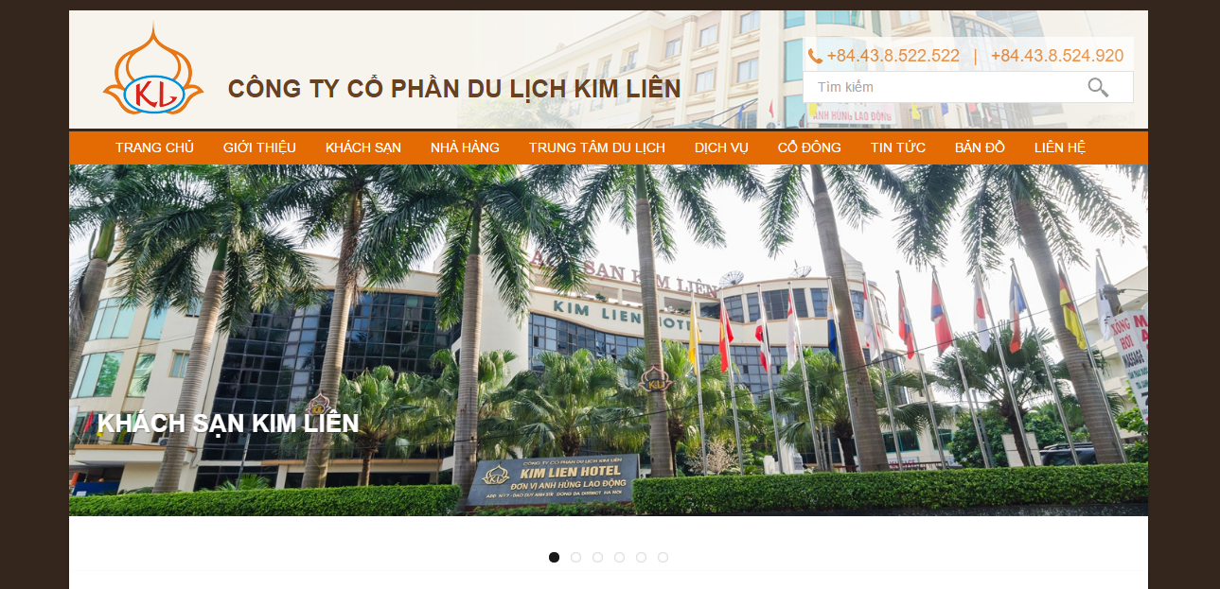
User interface design simple, friendly. Provide quite enough information about the hotel for guests
- “GIỚI THIỆU”: hotel profiles
- “KHÁCH SẠN”: information on facilities, rooms of the hotel, price
- “NHÀ HÀNG”, “TRUNG TÂM DU LỊCH”, “DỊCH VỤ”
- “CỔ ĐÔNG”: information on the operating apparatus, hotel management activities
- “TIN TỨC”, “BẢN ĐỒ”, “LIÊN HỆ”
However, the online booking function of hotel has not really optimized, many inadequacies and the implementation process is quite complex. Searching room information is not checked before execution, guests can not see basic information about rooms that can be booked.

Hilton Hotel
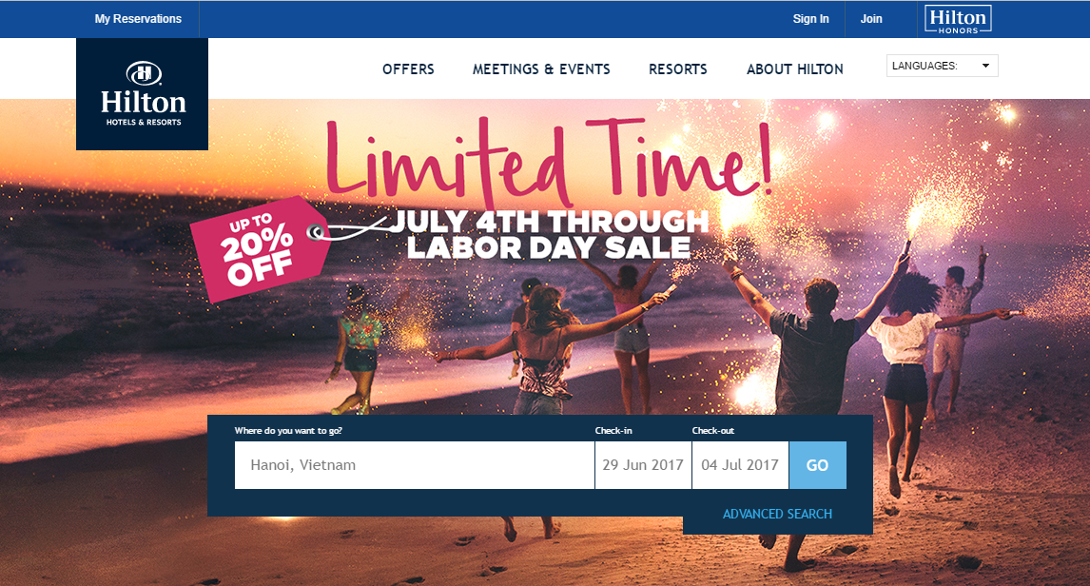
Website of Hilton hotel is designed simple, beautiful. That also provide basically information such as:
- Offers: providing for guests with special service packages
- Meetings & events: information for conferences, events featured in the hotel
- Resorts: information for resorts of hotel
- About Hilton: hotel profiles
- My reservation: search, change information of myself reservation
The online booking function of hotel is quite complete compared to Kim Lien hotel, but like Kim Lien, the online booking process is still complicated through many steps to complete the reservation

Comparison
This section will list some of the comparison criteria for HOWE with Kim Lien and Hilton hotel, which are built on the guest’s perspective of the system

Tiêu chí đánh giá | HOWE | Kim Lien Hotel | Hilton Hotel
Ease of use of the website
Simple design of the website
The simplicity of the online booking room function
Provided information on the website
Multi languages
Online payment

Software Project Management Plan (SPMP – Report 02)

Problem Definition

Name of this CapStone Project
Nội dung của dự án là phát triển một trang web quản lý khách sạn vì vậy nó được lấy tên là hotel website và gọi tắt là HOWE

Problem Abstract
Xây dung một phần mềm quản lý các hoạt động khách sạn. dựa trên các hệ thống đang được sử dụng hiện nay để phát triển một website quản lý phù hợp với đặc thù công việc của khách sạn, từ việc quản lý các dịch vụ, trang thiết bị đến quản lý nhân lực, cơ sở vật chất hay doanh thu, tài chính của khách sạn.

Project organization

Software Process Model
The figure below will describe the information and product’s flow lifecycle process model.

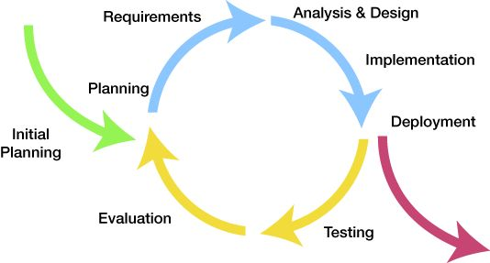
Figure 1.1 – Iterative software process model
This is the process model which HOWE used to develop our system. There are many others process model that were widely applied in the world such as Waterfall, Spiral, V-model, etc, but we chose Iterative Software Process Model because of these following reasons:
- The major requirements were defined clearly so by using this process model, we generate working software quickly and early during the sotfware life cycle.
- This model is more flexible – less costly to change scope and requirements.
- Easier to manage risk because risky pieces are identified and handle.
- When every single issue was discovered, it will be solved while the project is still on process.
After analyze, design, develope and test the main features of project, we will fix bugs, and test again. These actions will be repeated until the final product has been completed and ready to be packed.
The Iterative Process Model is suitable for team that doesn’t have much experience. It divides the development system task into smaller tasks which is easily review and rework.

Roles and Responsibilities

Organizational Structure 組織構造
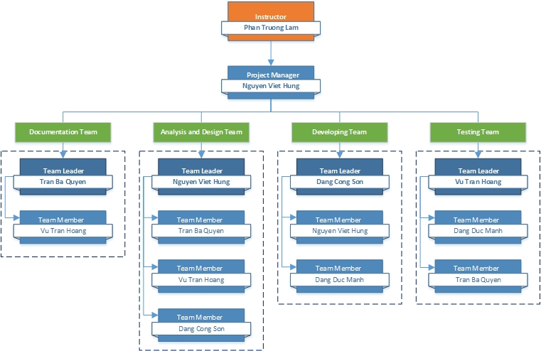

Project Team プロジェクトチーム
Role | Responsibility | Full name | % Effort | Start date | End date
Instructor | - Provide templates & tools  - Review deliverables  - Review project status  - Resolve escalated issues  - Consultant | Phan Trường Lâm | 10% | 8th May, 2017 | 26th August, 2017
PM | - Planning and defining scope  - Developing schedule  - Reviewing and tracking document  - Assign individual responsibility  - Assign task to team members | Nguyễn Việt Hưng | 100% | 8th May, 2017 | 26th August, 2017
Analysis and Design Team
Team Leader | - Reviewing and tracking design  - Identify main UI  - Draw prototype, architecture design  - Design Database | Nguyễn Việt Hưng | 100%
Team member #1 | - Draw prototype, architecture design | Trần Bá Quyền | 100%
Team member #2 | - Design database  - Design screen | Vũ Trần Hoàng | 100%
Team member #3 | - Design database  - Design screen | Đặng Công Sơn | 100%
Documentation Team
Team Leader | - Reviewing and tracking requirement | Trần Bá Quyền | 100%
Team member #1 | - Create SRS Document  - Create Final Report | Vũ Trần Hoàng | 100%
Team member #2 | - Create SRS Document  - Create Final Report | Đặng Đức Mạnh | 100%
Development Team
PTL | - Developing  - Solve issue of project | Đặng Công Sơn | 100%
Developer #1 | - Developing | Nguyễn Việt Hưng | 100%
QA and Testing Team
Test Leader | - Responsible for test excution | Vũ Trần Hoàng | 100%
Tester #1 | - Testing | Trần Bá Quyền | 100%
Tester #2 | - Testing | Đặng Đức Mạnh | 100%
Table 2.1 – Project Team

Tools and Techniques
- Techniques:
- Ngôn ngữ lập trình: PHP, HTML, CSS, Javascript, JQuery
- Frameword: laravel
- Database: PostgreSQL
- Tools:
- IDE: PHP Storm
- Database: pgAdmin 4
- TortoiseGit

Project management plan
2.3.1. Tasks:
2.3.1.n Task-n:
- Description
- Deliverables
- Resources Needed
- Dependencies and Constraints
- Risks
2.3.2. Task Sheet: Assignments and Timetable
2.3.3. All Meeting Minutes
<Put all your-team’s meeting minutes here as an appendix >

Coding Convention
These following rules follow the standard rules of developing application using PHP. It refers to the coding convention on websites:
https://www.codeigniter.com/user_guide/general/styleguide.html
File Format
Files should be saved with Unicode (UTF-8) encoding. The BOM should not be used. Unlike UTF-16 and UTF-32, there’s no byte order to indicate in a UTF-8 encoded file, and the BOM can have a negative side effect in PHP of sending output, preventing the application from being able to set its own headers. Unix line endings should be used (LF).
Here is how to apply these settings in some of the more common text editors. Instructions for your text editor may vary; check your text editor’s documentation.
PHP Closing Tag
The PHP closing tag on a PHP document ?> is optional to the PHP parser. However, if used, any whitespace following the closing tag, whether introduced by the developer, user, or an FTP application, can cause unwanted output, PHP errors, or if the latter are suppressed, blank pages. For this reason, all PHP files MUST OMIT the PHP closing tag and end with a single empty line instead.
File Naming
Class files must be named in an Ucfirst-like manner, while any other file name (configurations, views, generic scripts, etc.) should be in all lowercase.
INCORRECT:
- somelibrary.php
- applicationConfig.php
CORRECT:
- Somelibrary.php
- applicationconfig.php
Furthermore, class file names should match the name of the class itself. For example, if you have a class named Myclass, then its filename must be Myclass.php.
Class and Method Naming
Class names should always start with an uppercase letter. Multiple words should be separated with an underscore, and not CamelCased.
INCORRECT:
- class superclass
- class SuperClass
CORRECT:
- class Super_class {}
Class methods should be entirely lowercased and named to clearly indicate their function, preferably including a verb. Try to avoid overly long and verbose names. Multiple words should be separated with an underscore.
INCORRECT:
- function fileproperties() // not descriptive and needs underscore separator
- function fileProperties() // not descriptive and uses CamelCase
- function getfileproperties() // Better! But still missing underscore separator
- function getFileProperties() // uses CamelCase
CORRECT:
- function get_file_properties() // descriptive, underscore separator, and all lowercase letters
Variable Names
The guidelines for variable naming are very similar to those used for class methods. Variables should contain only lowercase letters, use underscore separators, and be reasonably named to indicate their purpose and contents. Very short, non-word variables should only be used as iterators in for() loops.
INCORRECT:
- $j = 'foo'; // single letter variables should only be used in for() loops
- $Str // contains uppercase letters
- $bufferedText // uses CamelCasing, and could be shortened without losing semantic meaning
- $groupid // multiple words, needs underscore separator
- $name_of_last_city_used // too long
CORRECT:
- for ($j = 0; $j < 10; $j++)
- $str
- $buffer
- $group_id
- $last_city
Commenting
In general, code should be commented prolifically. It not only helps describe the flow and intent of the code for less experienced programmers, but can prove invaluable when returning to your own code months down the line. There is not a required format for comments, but the following are recommended.
Comment code block:
/*
* @author Author Name
* @link http://example.com
*/
Use single line comments within code, leaving a blank line between large comment blocks and code:
- // break up the string by newlines
- // $parts = explode("\n", $str);
Constants
Constants follow the same guidelines as do variables, except constants should always be fully uppercase. Always use CodeIgniter constants when appropriate, i.e. SLASH, LD, RD, PATH_CACHE, etc.
INCORRECT:
- myConstant // missing underscore separator and not fully uppercase
- N // no single-letter constants
- S_C_VER // not descriptive
- $str = str_replace('{foo}', 'bar', $str); // should use LD and RD constants
CORRECT:
- MY_CONSTANT
- NEWLINE
- SUPER_CLASS_VERSION
- $str = str_replace(LD.'foo'.RD, 'bar', $str);

MEETING MINUTES 打ち合わせ議事録
All meeting minutes will be written follow this template:
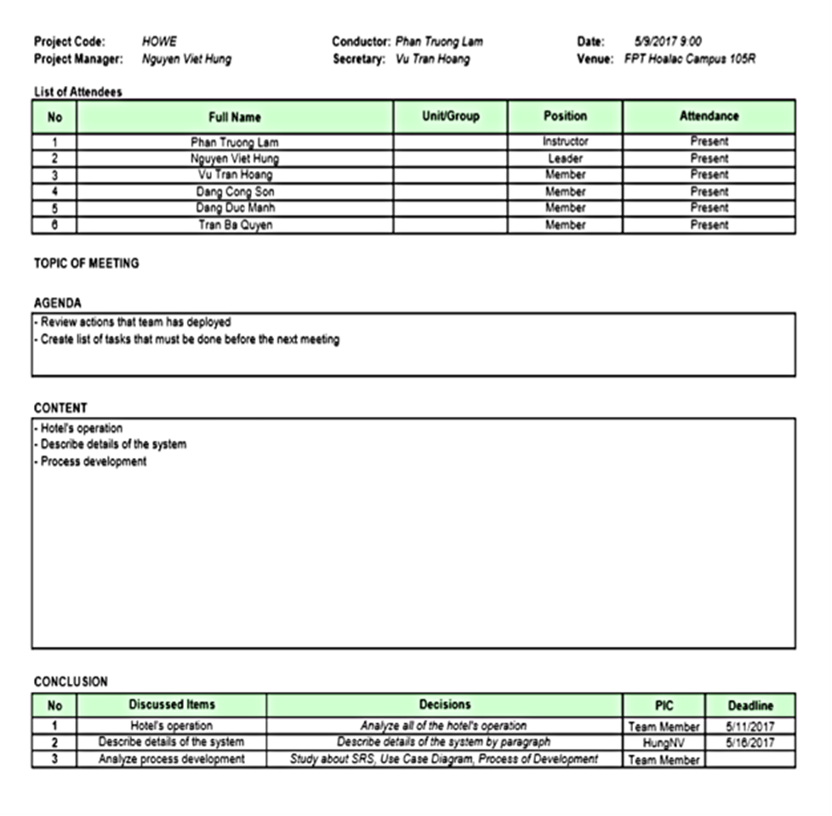
Figure 1.2 – Meeting Minutes

PROJECT MILLSTONES プロジェクトマイルストーン

No | Milestone | Completion Date | Verification
1 | Project Start | May 8th, 2017 | Instructor approval
2 | Submit report 1 | May 22nd, 2017 | Instructor approval
3 | Submit report 2 | June 5th, 2017 | Instructor approval
4 | Submit report 3 | June 19th, 2017 | Instructor approval
5 | Submit report 4 | July 24th, 2017 | Instructor approval
6 | Submit report 5 | August 7th,2017 | Instructor approval
7 | Submit report 6 | August 21st, 2017 | Instructor approval
9 | Defend project |  | Instructor approval
Table 2.2 – Project Milestones

RESOURCES リソース

Human resource 人的リソース
- Team members
- Supervisor

Non-human resource 機器やツール
- Equipment: Desktop, Laptop
- Building: Alpha & Beta Building of FPT University Hoalac Campus

RISK MANAGEMENT リスク管理
No. | Name | Root Cause | Probability | Avoidance plan | Contingency plan | Impact
1 | Project team don’t meet the deadline on time. | Members lack of responsibility  Lack of management. | Medium | Make rules and penalties for member who didn’t meet the deadline. | Working overtime to complete tasks on time. | High
2 | Requirement changed while project is being processed. | SRS is not provide all information about user requirement such as: lack of customer’s requirement, misunderstand customer’s requirement. | High | SRS should be reviewed carefully by PM and Supervisor.  Always do brainstorming carefully to design detail system. Hold all meeting and make minimize effort to change and improve design by requirement changes. | Team members will have meetings with supervisor to analyze the requirement changes, and make a specific action to resolve that problem. | High
3 | Delivery does not meet the deadine. | Team members work late, lack of responsible causing not meet project schedule. | High | Assign tasks to suitable team members depend on their ability. | Team leader should regularly care about dealine and project schedule to inform members.  Break down task to smaller tasks and assign new tasks to team members. | Medium
4 | Lack of knowledge about technology needs for project. | Depend on requirement, new technology should be apply in the project, which some team members haven’t used before. | Medium | Each team members must study to understand the technology, framework which is needed for project. | Technical leader need to support carefully for team members in group to increase required skill and knowledge.  Review complete task to make comment for team members. | Medium
5 | Conflict among team members. | Team members don’t understand each other. | High | Plan some team building activities to improve the relationship between team members.  Clear role and responsibility for each member. | Have a meeting to resolve conflict problems. | High
6 | Data or Source Code Lost | Delete Brand on GitHub.  Delete wrong source code. | Medium | Back up source code carefully.  Commit all small tasks after completed to GitHub. | Restore data from backed up data.  Restore source code from history versions. | High

Table 2.3 – Risk Management

COMMUNICATION MANAGEMENT コミュニケーション管理

Communication between Team Members チームメンバーの間のコミュニケーション
- Face-to-face meeting: at least twice a week on Tuesday and Thursday. This is the fastest way of communication to solve big problems in the project and members can help out each other easily.
- E-mail and message: Email, Skype and Facebook are used for members to keep tracking other team member’s progress and team members can also help each other online.
- Mobile Phone: is using for emergency situation to directly contact to others.
- Collaboration tool: GitHub is used for document and source code management.

Communication with Supervisor 指導教員とコミュニケーション
- Face-to-face meeting: Weekly on every Tuesday morning to make sure that supervisor can keep tracking of the team’s progress.
- E-mail: Gmail is the fastest way to get advice and document checking from supervisor.
- Mobile phone: is used to get time and place arranged for the meeting every week.

CONFIGURATION MANAGEMENT PROCESS コンフィグレーション管理のプロセス

CI Identification and Naming Convention 構成アイテムと命名規則

No | Configuration Items | Naming Convention
Project Management
1 | Project Plan
Requirement & Design
2 | SRS
3 | Architectural Design
4 | Screen Design
5 | Data Design
Source Code
6 | Source Code
Support Document
7 | User Manual
Test
8 | Unit Test Plan
9 | Integration Test Plan
10 | System Test Plan
11 | Unit Test Case
12 | Integration Test Case
13 | System Test Case
14 | Test Data
15 | Test Result
Process
16 | Guideline
17 | Template
18 | Checklist
File Type
19 | MS Word | *.docx
20 | MS Excel | *.xlsx
21 | MS PowerPoint | *.pptx
22 | MS Project Plan | *.mpp
23 | Images | *.png or *.jpg or *.jpeg or *.bmp or*.gif
Table 2.4 – Naming Convetion

Project Infrastructure プロジェクトインフラストラクチャ
Below is the list of tools and infrastructure requirements needed for development environment.

Software ソフトウェア
Operating system | Microsoft Windows 10
Programming languages | PHP 5, HTML, CSS, Javascript, JQuery
Framework | Laravel 5.4, Bootstrap 3.3.4
Version Control | Github 2.4
IDEs | PHPStorm v2017.2, Notepad++, pgAdmin 4
DBMS | PostgreSQL
Deployment tools
Communication tools | Skype, Facebook, Phone, Email.
UML tools | Astah Professional 7.1.0
UI design tool | Balsamiq Mockups
Management tools | Microsoft Project Professional 2016
Web server | Homestead 7
Documentation | Microsoft Word 2016
Documentation | Microsoft Excel 2016
Documentation | Microsoft PowerPoint 2016
Table 2.5 – Tools needed for project

Hardware ハードウェア
- 5 laptops for developing, testing and creating documents with the configuration: 4GB Ram, 256GB of hard disk, Intel Core i5 processor.
- Internet network connection with minium speed 512kbit/s

Other infrastructure その他のインフラストラクチャ
- Rooms for meeting and working.
- Internet and mobile phone service for communication.

Directory structure ディレクトリ構造
Main folder | Sub-folder | Purpose
Table 2.6 – Directory structure

Software Requirements Specifications (SRS – Report 03)

User Requirement Specification

When using HOWE, users can easily find information about the hotel, seeing room status as well as the facilities and services of the hotel, giving customers the most intuitive view of the hotel without to the place. By booking online to help customers minimize the time, cost savings improve work efficiency. Moreover, the HOWE system also provides users with the most up-to-date information about the resort, food, entertainment, etc… to make the perfect choice.

System Requirement Specification (Specific Requirements)

Business Rule
No | Description
B1 | Customer can’t book more than 2 months before check-in date
B2 | Customer can book room at least one day before check-in date
B3 | Actor can only send feedback via the attachment link in the booking information mail
B4 | Password is at least 8 characters including letters and numbers and must not be similar to 2 most recent passwords
B5 | Guest must pay all charges in accordance with the hotel
B6 | Comply with the cancellation policy of the hotel
B7 | The room is checked in status
B8 | Username is setted by format: Uxxxx(x is a digital)
B9 | Password is at least 8 characters including letters and numbers
Table 3.1 – Bussiness Rule

Functional Requirement

Guest

Use Case Diagram

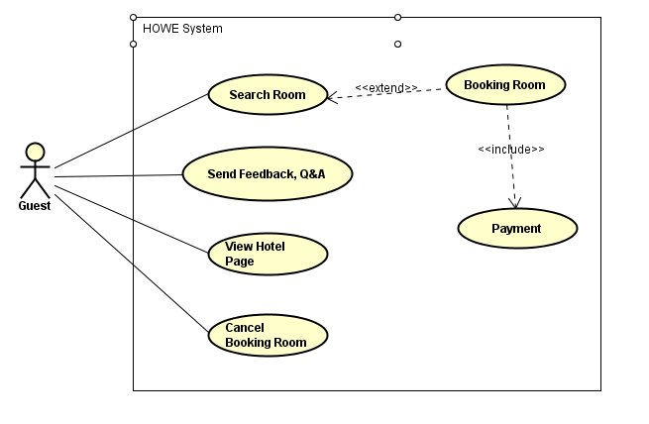
Figure 1.3 – Guest Use Case Diagram

Use Case Specification

UC001 - Search Room
Use Case ID: |  | UC001 |  | Version: | 1.0
Use Case Name: |  | Search Room |  | Priority: | High
Created by: |  | QuyenTB |  | Date Created: | 29/05/2017
Actors: |  | Guest
Description: |  | This function allows actor to find room’s information and view room’s detail information without booking
Trigger: |  | Click on “Book Now” button on the HomePage
Normal Flow
No | Actor Events |  |  | System Response
 | Click on “Book Now” button
 |  |  |  | Display booking page
 | Select check-in, check-out date, enter information then click “Apply” button
 |  |  |  | Display the list of rooms and the number of available rooms corresponding to the search conditions
Extension Flows
ET1 | At step 3 is repeated
Exceptions:
EC1 | At step 3, required fields are not entered
No | Actor Events |  |  | System Response
3.1 |  |  |  | Display message prompts for data entry, focus on mandatory object
Business Rules: |  |  | N/A
Other Information: |  |  | N/A

UC002 - Booking room
Use Case ID: |  | UC002 |  | Version: | 1.0
Use Case Name: |  | Booking room |  | Priority: | High
Created by: |  | QuyenTB |  | Date Created: | 29/05/2017
Actors: |  | Guest
Description: |  | This function allows actor to find and book a room
Trigger: |  | Click on “Book Now” button on the HomePage
Normal Flow
No | Actor Events |  |  | System Response
1 | Click on “Book Now” button
2 |  |  |  | Display booking page
3 | Select check-in, check-out date, enter information then click “Apply” button
4 |  |  |  | Display the list of rooms and the number of available rooms corresponding to the search conditions
5 | Input quantity for each room type then click on “Next” button
6 |  |  |  | Display confirmation booking page in the new tab
7 | Enter customer and payment information then click on “Đặt phòng” button
8 |  |  |  | Display successfully message, display homepage, send booking information to customer’ mail
Extension Flows
ET1 | Step 3 is repeated
ET2 | At step 7
No | Actor Events |  |  | System Response
7.1 | Click on “Hủy bỏ” button
8.1 |  |  |  | Close confirmation tab
Exceptions:
EC1 | At step 5, number of room is not inputted
No | Actor Events |  |  | System Response
5.1 | Click on “Next” button
6.1 |  |  |  | Display notification popup
EC2 | At step 7, data is not inputted
No | Actor Events |  |  | System Response
7.1 | Click on “Đặt phòng” button
8.1 |  |  |  | Display notification popup
EC3 | At step 7, payment method is not chosen
7.1 |  |  |  | Display notification popup
Business Rules: |  |  | Customer can’t book more than 2 months before check-in date
Other Information: |  |  | N/A

Oki---UC003 - Send feedback, Q&A
Use Case ID: |  | UC003 |  | Version: | 1.0
Use Case Name: |  | Send Feedback, Q&A |  | Priority: | High
Created by: |  | QuyenTB |  | Date Created: | 29/05/2017
Actors: |  | Guest
Description: |  | This function allows actor send feedback, Q&A about Hotel to hotel’s E-mail
Trigger: |  | Click on “Feedback, Q&A” link attached in the check-out information email
Normal Flow
No | Actor Events |  |  | System Response
 | Click on “Feedback, Q&A” link
 |  |  |  | Display survey
 | Complete survey then click on “Gửi” button
4 |  |  |  | Display notification message
Exceptions:
EC1 | At step 3, any answer are not chosen
No | Actor Events |  |  | System Response
3.1 |  |  |  | Display message required choosing answer
Business Rules: |  |  | Actor can only send feedback via the attachment link in the check-out information mail
Other Information: |  |  | N/A

Oki---UC004 - View hotel page
Use Case ID: |  | UC004 |  | Version: | 1.0
Use Case Name: |  | View hotel page |  | Priority: | High
Created by: |  | QuyenTB |  | Date Created: | 29/05/2017
Actors: |  | Guest
Description: |  | Actor can view hotel page
Trigger: |  | Click on logo of hotel on the website
Normal Flow
No | Actor Events |  |  | System Response
 | Click on logo of hotel
 |  |  |  | Display hotel page
Alternative Flows
AT1 | At step 1
No | Actor Events |  |  | System Response
1.1 | Click on other button or link
2.1 |  |  |  | Display selected button or link page
Business Rules: |  |  | N/A
Other Information: |  |  | N/A

UC005 - Cancel Booking Room
Use Case ID: |  | UC005 |  | Version: | 1.0
Use Case Name: |  | Cancel Booking Room |  | Priority: | High
Created by: |  | QuyenTB |  | Date Created: | 29/05/2017
Actors: |  | Guest
Description: |  | This function allows actor cancel the room they have booked
Trigger: |  | Click on cancellation booking link attached in the booking information email
Normal Flow
No | Actor Events |  |  | System Response
 | Click on cancellation booking link attached in the booking information email
 |  |  |  | Display booked room details information
 | Click on “I agree” checkbox then click on “Next” button
 |  |  |  | Display successfully notification, send cancellation booking rooms information mail to customer
Exception Flows
EC1 | At step 3, actor do not click on checkbox
3.1 |  |  |  | Display message request for confirmation of cancellation
Business Rules: |  |  | Guest must pay all charges in accordance with the hotel
Other Information: |  |  | N/A

Receptionist

Use Case Diagram
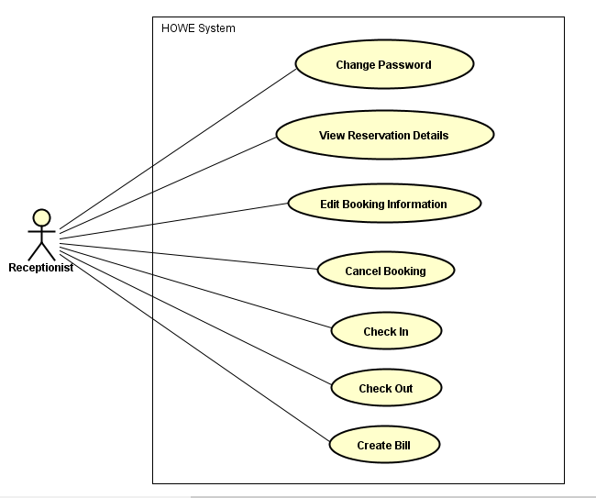
Figure 1.4 – Receptionist Use Case Diagram

Use Case Specification

UC006 - View Hotel Page
The same with description of UC004

Oki---UC007 - Change Password
Use Case ID: |  | UC007 |  | Version: | 1.0
Use Case Name: |  | Change Password |  | Priority: | High
Created by: |  | QuyenTB |  | Date Created: | 29/05/2017
Actors: |  | Receptionist
Description: |  | This function allows actor to change password of own account
Trigger: |  | Click on name of actor on navigation form
Normal Flow
No | Actor Events |  |  | System Response
 | Click on name of actor
 |  |  |  | Display actor information
 | Click on “Đổi mật khẩu” button
4 |  |  |  | Display change password form
5 | Enter information then click on “Thay đổi” button
6 |  |  |  | Display successfully message, display actor information page
Extension Flows
ET1 | At step 3
No | Actor Events |  |  | System Response
3.1 | Click on “Quay lại” button
4.1 |  |  |  | Display previous page
Exceptions:
EC1 | At step 3, required fields are not entered
No | Actor Events |  |  | System Response
3.1 |  |  |  | Display message prompts for data entry, focus on mandatory objects
EC2 | At step 5
No | Actor Events |  |  | System Response
5.1 | Input invalid old password then click “Thay đổi” button
6.1 |  |  |  | Display error message and focus on error objects
EC3 | At step 5, new password and confirm new password are not similar
No | Actor Events |  |  | System Response
5.1 | Click on “Thay đổi” button
6.1 |  |  |  | Display error message and focus on error objects
Business Rules: |  |  | Password must be set according to rules: at least 8 characters
Other Information: |  |  | N/A

Oki---UC008 - View Reservation Details
Use Case ID: |  | UC008 |  | Version: | 1.0
Use Case Name: |  | View Reservation Details |  | Priority: | High
Created by: |  | QuyenTB |  | Date Created: | 29/05/2017
Actors: |  | Receptionist
Description: |  | This function allows actor cancel information of all reservation
Trigger: |  | Click on “Chi tiết đơn đặt” on the management page
Normal Flow
No | Actor Events |  |  | System Response
 | Click on “Chi tiết đơn đặt”
 |  |  |  | Display reservation page
 | Enter searching information then click on “Tìm kiếm” button
 |  |  |  | Display list of reservation corresponding with searching conditions
6 | Select the reservation
7 |  |  |  | Display details of reservation
Extension Flows
ET1 | At step 3, searching information are not entered
No | Actor Events |  |  | System Response
3.1 | Click on “Tìm kiếm” button
4.1 |  |  |  | Display list of all reservation
ET2 | At step 3
No | Actor Events |  |  | System Response
3.1 | Click on “Quay lại” button
4.1 |  |  |  | Display previous page
ET3 | At step 3 is repeated
Business Rules: |  |  | N/A
Other Information: |  |  | N/A

Oki---UC009 - Edit Booking Information
Use Case ID: |  | UC009 |  | Version: | 1.0
Use Case Name: |  | Edit Booking Information |  | Priority: | High
Created by: |  | QuyenTB |  | Date Created: | 29/05/2017
Actors: |  | Receptionist
Description: |  | This function allows actor to change information of reservation
Trigger: |  | Click on “Chi tiết đơn đặt” on the management page
Normal Flow
No | Actor Events |  |  | System Response
 | Click on “Chi tiết đơn đặt”
 |  |  |  | Display reservation page
 | Enter searching information then click on “Tìm kiếm” button
 |  |  |  | Display list of reservation corresponding with searching conditions
5 | Select the reservation
6 |  |  |  | Display details of reservation
7 | Edit information then click “Lưu” button
8 |  |  |  | Display confirmation dialog
9 | Click on “Đồng ý” button
10 |  |  |  | Display successfully message, display list of reservation
Extension Flows
ET1 | Step 3 is repeated
ET2 | At step 3
No | Actor Events |  |  | System Response
3.1 | Click on “Đóng” button
4.1 |  |  |  | Display previous page
ET3 | At step 3, searching information are not entered
No | Actor Events |  |  | System Response
3.1 | Click on “Tìm kiếm” button
4.1 |  |  |  | Display list of all reservation
ET4 | At step 7
No | Actor Events |  |  | System Response
7.1 | Click on name of room type in the “Loại phòng” column
7.2 |  |  |  | Display room type information
7.3 | Select room number then click on “Lưu” button
7.4 |  |  |  | Goto step 7 in the main flow
ET5 | At step 7
No | Actor Events |  |  | System Response
7.1 | Click on “Đóng” button
8.1 |  |  |  | Display previous page
ET3 | At step 9
No | Actor |  |  | System Response
11.1 | Click on “x” button of dialog
12.1 |  |  |  | Display detail reservation view with editing information
Exceptions:
EC1 | At step 7, required fields are not entered
No | Actor Events |  |  | System Response
7.1 |  |  |  | Display message prompts for data entry, focus on mandatory objects
EC2 | At step 9, entered information are not correct
No | Actor Events |  |  | System Response
7.1 |  |  |  | Display error message
Business Rules: |  |  | Guest must pay all charges accordance hotel’s rules
Other Information: |  |  | N/A

Oki---UC010 - Cancel Booking
Use Case ID: |  | UC010 |  | Version: | 1.0
Use Case Name: |  | Cancel Booking |  | Priority: | High
Created by: |  | QuyenTB |  | Date Created: | 29/05/2017
Actors: |  | Receptionist
Description: |  | This function allows actor cancel the room they have booked
Trigger: |  | Click on “Danh sách phòng” on the receptionist management page
Normal Flow
No | Actor Events |  |  | System Response
 | Click on “Danh sách phòng”
 |  |  |  | Display list of reservation page
 | Enter searching information then click on “Tìm” button
 |  |  |  | Display list of reservation corresponding to the search conditions
 | Select the reservation
6 |  |  |  | Display details of reservation
7 | Change status to cancelled then click on “Lưu” button
8 |  |  |  | Display confirmation popup
9 | Click on “OK” button
10 |  |  |  | Display successfully message, display list of reservation
Extension Flows
ET1 | Step 3 is repeated
ET2 | At step 7
No | Actor Events |  |  | System Response
7.1 | Click on “Quay lại” button
8.1 |  |  |  | Display list of reservation
ET3 | At step 9
No | Actor Events |  |  | System Response
9.1 | Click on “Hủy” button of popup
10.1 |  |  |  | Display reservation detail page with new status
ET4 | At step 7
No | Actor Events |  |  | System Response
7.1 | Select other status or edit data
8.1 |  |  |  | Go to UC009 – Edit Booking Information
Business Rules: |  |  | Comply with the cancellation policy of the hotel
Other Information: |  |  | N/A

Oki---UC012 - Check In
Use Case ID: |  | UC012 |  | Version: | 1.0
Use Case Name: |  | Check In |  | Priority: | High
Created by: |  | HoangVT |  | Date Created: | 29/05/2017
Actors: |  | Receptionist
Description: |  | This function allows actor check-in for guest
Trigger: |  | Click on “Nhận phòng” on the receptionist management page
Normal Flow
No | Actor Events |  |  | System Response
 | Click on “Nhận phòng” button
 |  |  |  | Display check-in information page
 | Enter data then click on “Tìm” button
4 |  |  |  | Display list of reservation corresponding to the search conditions
5 | Click on “Nhận phòng” link
6 |  |  |  | Display check-in form
7 | Confirm information with customer then click on “Check in” button
8 |  |  |  | Display successful message, display check-in information page
Extension Flows
ET1 | At step 3
No | Actor Events |  |  | System Response
3.1 | Click on “Quay lại” button
4.1 |  |  |  | Display receptionist management page
ET2 | At step 3
No | Actor Events |  |  | System Response
3.1 | Click on “Tìm” button
6.1 |  |  |  | Display all reservation with waiting status
ET1 | At step 7
No | Actor Events |  |  | System Response
7.1 | Click on “Đóng” button
8.1 |  |  |  | Display check-in information page
Exceptions:
EC1 | At step 7, required fields is not entered
No | Actor Events |  |  | System Response
8.1 |  |  |  | Display message prompts for data entry, focus on mandatory objects
Business Rules: |  |  | N/A
Other Information: |  |  | N/A

UC013 - Check Out
Use Case ID: |  | UC013 |  | Version: | 1.0
Use Case Name: |  | Check Out |  | Priority: | High
Created by: |  | HoangVT |  | Date Created: | 29/05/2017
Actors: |  | Receptionist
Description: |  | This function allows actor check-out for customer
Trigger: |  | Click on “Room’s Status” on the management page
Normal Flow
No | Actor Events |  |  | System Response
 | Click on “Room’s Status” button
 |  |  |  | Display all room’s status
 | Right click on the room number then click on “Check Out”
4 |  |  |  | Display check-out form
5 | Click on “Check Out” button
6 |  |  |  | Display check-out bill details
7 | Click on “Save&Print” button
8 |  |  |  | Display successfully message, display management page
Extension Flows
ET1 | At step 7 in main flow
No | Actor Events |  |  | System Response
7.1 | Click on “Cancel” button
8.1 |  |  |  | Display all room’s status
Business Rules: |  |  | - Guest must pay all charges according to hotel’s rules  - The room is checked in status
Other Information: |  |  | N/A

UC014 - Create Bill
Use Case ID: |  | UC014 |  | Version: | 1.0
Use Case Name: |  | Create Bill |  | Priority: | High
Created by: |  | HoangVT |  | Date Created: | 29/05/2017
Actors: |  | Receptionist
Description: |  | This function allows actor to create bill
Trigger: |  | Click on “Finance Management” on the management page
Normal Flow
No | Actor Events |  |  | System Response
 | Click on “Finance Management” then click on “Create Bill”
 |  |  |  | Display creating bill form
 | Enter bill information then click on “Next” button
4 |  |  |  | Display details information of bill
5 | Click “Save&Print” button
6 |  |  |  | Display successfully message, display management page
Extension Flows
ET1 | At step 5
No | Actor Events |  |  | System Response
5.1 | Click on “Cancel”
5.2 |  |  |  | Display creating bill form with entered information
Exceptions:
EC1 | At step 3, required fields is not entered
No | Actor Events |  |  | System Response
3.1 |  |  |  | Display message prompts for data entry, focus on mandatory objects
Business Rules: |  |  | Guest must pay all charges in accordance with the hotel
Other Information: |  |  | N/A

Manager

Use Case Diagram
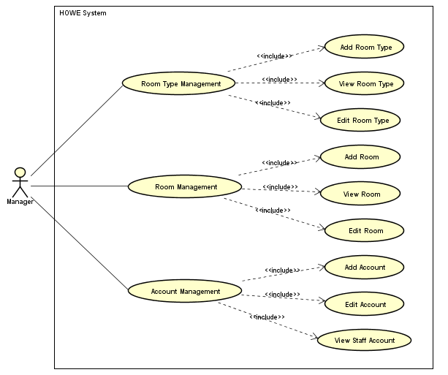
Figure 1.5 – Manager Use Case Diagram

Use Case Specification

Oki---UC015 – View Room Type
Use Case ID: |  | UC015 |  | Version: | 1.0
Use Case Name: |  | View Room Type |  | Priority: | High
Created by: |  | HoangVT |  | Date Created: | 29/05/2017
Actors: |  | Manager
Description: |  | This function allows actor view room type
Trigger: |  | Click on “Quản lý loại phòng” on the management page
Normal Flow
No | Actor Events |  |  | System Response
1 | Click on “Quản lý loại phòng” button
2 |  |  |  | Display view room type form
3 | Select room type and click on “Xem” button
4 |  |  |  | Display room type information details
Extension Flows
ET1 | At step 3 in the main flows
No | Actor Events |  |  | System Response
3.1 | Click on “Thêm mới” button
4.1 |  |  |  | Go to UC016 – Add Room Type
ET2 | At step 3 in the main flows
No | Actor Events |  |  | System Response
3.1 | Click on “Lưu” button
4.1 |  |  |  | Display notification message
ET3 | At step 3 in the main flows
No | Actor Events |  |  | System Response
3.1 | Click on “Quay lại” button
4.1 |  |  |  | Display previous page
ET4 | At step 3 in the main flows
No | Actor Events |  |  | System Response
3.1 | Click on “Thêm thiết bị” or “Xóa” button
4.1 |  |  |  | Go to UC017 – Edit Room Type
ET5 | At step 3 is repeated
Exception
EC1 | At step 5, required fields are not entered
No | Actor Events |  |  | System Response
5.1 |  |  |  | Display message prompts for data entry, focus on mandatory objects
Business Rules: |  |  | N/A
Other Information: |  |  | N/A

Oki---UC016 – Add Room Type
Use Case ID: |  | UC016 |  | Version: | 1.0
Use Case Name: |  | Add Room Type |  | Priority: | High
Created by: |  | HoangVT |  | Date Created: | 29/05/2017
Actors: |  | Manager
Description: |  | This function allows actor add new room type
Trigger: |  | Click on “Quản lý loại phòng” on the management page
Normal Flow
No | Actor Events |  |  | System Response
1 | Click on “Quản lý loại phòng” button
2 |  |  |  | Display view room type form
3 | Click on “Thêm mới” button
4 |  |  |  | Display add room type form
5 | Enter room and accessories information
6 | Click on “Thêm kiểu phòng” button
7 |  |  |  | Display successfully message, display view room type page
Extension Flows
ET1 | At step 3, actor click on other button or link
No | Actor Events |  |  | System Response
4.1 |  |  |  | Redirect to selected button or link
ET2 | At step 6 in the main flows
No | Actor Events |  |  | System Response
6.1 | Click on “Thêm thiết bị” button
6.2 |  |  |  | Insert new row of accessory into accessory table
ET3 | At step 6 in the main flows
No | Actor Events |  |  | System Response
6.1 | Click on “Xóa” button
6.2 |  |  |  | Delete the last row in the accessory table
ET4 | At step 6 in the main flows
No | Actor Events |  |  | System Response
6.1 | Click on “Hủy bỏ” button
7.1 |  |  |  | Display previous page
ET5 | At step 5 is repeated
Exception
EC1 | At step 5, required fields are not entered
No | Actor Events |  |  | System Response
5.1 |  |  |  | Display message prompts for data entry, focus on mandatory objects
Business Rules: |  |  | N/A
Other Information: |  |  | N/A

Oki---UC017 – Edit Room Type
Use Case ID: |  | UC017 |  | Version: | 1.0
Use Case Name: |  | Edit Room Type |  | Priority: | High
Created by: |  | HoangVT |  | Date Created: | 29/05/2017
Actors: |  | Manager
Description: |  | This function allows actor view and edit room type
Trigger: |  | Click on “Quản lý loại phòng” on the management page
Normal Flow
No | Actor Events |  |  | System Response
1 | Click on “Quản lý loại phòng” button
2 |  |  |  | Display view room type form
3 | Select room type and click on “Xem” button
4 |  |  |  | Display room type information details
5 | Edit information then click “Lưu” button
6 |  |  |  | Display confirmation message
7 | Click “Đồng ý”
8 |  |  |  | Display successfully message, display view room type page
Extension Flows
ET1 | At step 5 in the main flows
No | Actor Events |  |  | System Response
5.1 | Click on “Thêm thiết bị” button
5.2 |  |  |  | Insert new row of accessory into accessories table
ET2 | At step 5 in the main flows
No | Actor Events |  |  | System Response
5.1 | Click on “Xóa” button
5.2 |  |  |  | Delete the last row in the accessories table
ET3 | At step 3 in the main flows
No | Actor Events |  |  | System Response
3.1 | Click on “Hủy bỏ” button
4.1 |  |  |  | Display previous page
ET4 | At step 5 in the main flows, actor click on other button or link
No | Actor Events |  |  | System Response
6.1 |  |  |  | Redirect to selected button or link
ET5 | At step 7 in the main flows, click on “x” button of the confirmation message form
No | Actor Events |  |  | System Response
8.1 |  |  |  | Display view room type form with edited information
Exception
EC1 | At step 5, required fields are not entered
No | Actor Events |  |  | System Response
5.1 |  |  |  | Display message prompts for data entry, focus on mandatory objects
EC2 | At step 5, enter existed room type name
No | Actor Events |  |  | System Response
5.1 | Click on “Lưu” button
6.1 |  |  |  | Display error message
Business Rules: |  |  | N/A
Other Information: |  |  | N/A

Oki---UC018 – View Room
Use Case ID: |  | UC018 |  | Version: | 1.0
Use Case Name: |  | View Room |  | Priority: | High
Created by: |  | HoangVT |  | Date Created: | 29/05/2017
Actors: |  | Manager
Description: |  | This function allows actor view room information
Trigger: |  | Click on “Quản lý phòng” on the management page
Normal Flow
No | Actor Events |  |  | System Response
1 | Click on “Quản lý phòng” button
2 |  |  |  | Display view room list form
3 | Select floor, input search key then click on “Tìm” button
4 |  |  |  | Display list of room according searching conditions
5 | Click on room number link
6 |  |  |  | Display details information of the room
Extension Flows
ET1 | At step 3, actor click on other button or link
No | Actor Events |  |  | System Response
4.1 |  |  |  | Redirect to selected button or link
ET2 | At step 3 in the main flows
No | Actor Events |  |  | System Response
3.1 | Do not select and input data, click on “Tìm” button
4.1 |  |  |  | Display list of all room
ET3 | At step 3 in the main flows
No | Actor Events |  |  | System Response
3.1 | Click on “Quay lại” button
4.1 |  |  |  | Display previous page
ET4 | At step 3 in the main flows
No | Actor Events |  |  | System Response
3.1 | Click on “Danh sách” button
4.1 |  |  |  | Display list of all room
ET5 | At step 3 is repeated
Business Rules: |  |  | N/A
Other Information: |  |  | N/A

Oki---UC019 – Add Room
Use Case ID: |  | UC019 |  | Version: | 1.0
Use Case Name: |  | Add Room |  | Priority: | High
Created by: |  | HoangVT |  | Date Created: | 29/05/2017
Actors: |  | Manager
Description: |  | This function allows actor add new room
Trigger: |  | Click on “Quản lý phòng” on the management page
Normal Flow
No | Actor Events |  |  | System Response
1 | Click on “Quản lý phòng” button
2 |  |  |  | Display view room list form
3 | Click on “Thêm mới” button
4 |  |  |  | Display add room form
5 | Select room type
6 |  |  |  | Display room type information in the right hand
7 | Enter data then click on “Thêm” button
8 |  |  |  | Display successfully message, display view room page
Extension Flows
ET1 | At step 7, actor click on other button or link
No | Actor Events |  |  | System Response
7.1 |  |  |  | Redirect to selected button or link
ET2 | At step 7 in the main flows
No | Actor Events |  |  | System Response
7.1 | Click on “Tạo lại” button
7.2 |  |  |  | Display add room form with initial value
ET3 | At step 7 in the main flows
No | Actor Events |  |  | System Response
7.1 | Click on “Hủy bỏ” button
8.1 |  |  |  | Display previous page
ET5 | At step 7 is repeated
Exception
EC1 | At step 7, required fields are not entered
No | Actor Events |  |  | System Response
7.1 |  |  |  | Display message prompts for data entry, focus on mandatory objects
EC2 | At step 7, required fields are not entered
No | Actor Events |  |  | System Response
7.1 | Enter existed code of room
8.1 |  |  |  | Display error message, focus on error object
Business Rules: |  |  | N/A
Other Information: |  |  | N/A

Oki---UC020 – Edit Room
Use Case ID: |  | UC020 |  | Version: | 1.0
Use Case Name: |  | Edit Room |  | Priority: | High
Created by: |  | HoangVT |  | Date Created: | 29/05/2017
Actors: |  | Manager
Description: |  | This function allows actor view and edit room information
Trigger: |  | Click on “Quản lý phòng” on the management page
Normal Flow
No | Actor Events |  |  | System Response
1 | Click on “Quản lý phòng” button
2 |  |  |  | Display view room list form
3 | Select floor, enter searching key then click on “Tìm” buton
4 |  |  |  | Display list room according searching conditions
5 | Click on room number link
6 |  |  |  | Display detail information of the room
7 | Select room type
8 |  |  |  | Display room type information in the right hand
9 | Edit information then click on “Lưu” button
10 |  |  |  | Display confirmation message
11 | Click on “Đồng ý”
12 |  |  |  | Display successfully message, display view room list page
Extension Flows
ET1 | At step 7, actor click on other button or link
No | Actor Events |  |  | System Response
7.1 |  |  |  | Redirect to selected button or link
ET2 | At step 7 is repeated
ET3 | At step 9 in the main flows
No | Actor Events |  |  | System Response
9.1 | Click on “Tạo lại” button
10.1 |  |  |  | Display view room information form with initial value
ET4 | At step 9 in the main flows
No | Actor Events |  |  | System Response
9.1 | Click on “Hủy bỏ” button
10.1 |  |  |  | Display previous page
ET5 | At step 11 in the main flows
No | Actor Events |  |  | System Response
11.1 | Click on “x” button of confirmation message
12.1 |  |  |  | Display details room information form with edited data
Exception
EC1 | At step 9, required fields are not entered
No | Actor Events |  |  | System Response
9.1 |  |  |  | Display message prompts for data entry, focus on mandatory objects
EC2 | At step 9
No | Actor Events |  |  | System Response
9.1 | Enter existed room number then click on “Lưu” button
10.1 |  |  |  | Display error message, focus on room number object
Business Rules: |  |  | N/A
Other Information: |  |  | N/A

Oki---UC021 - View Staff Account
Use Case ID: |  | UC021 |  | Version: | 1.0
Use Case Name: |  | View Staff Account |  | Priority: | High
Created by: |  | HoangVT |  | Date Created: | 29/05/2017
Actors: |  | Manager
Description: |  | This function allows actor view staff account information
Trigger: |  | Click on “Quản lý tài khoản” on the management page
Normal Flow
No | Actor Events |  |  | System Response
1 | Click on “Quản lý tài khoản”
2 |  |  |  | Display list of accounts form
3 | Select staff position, enter searching data then click “Tìm” button
4 |  |  |  | Display list of account according searching conditions
5 | Click on login username link
6 |  |  |  | Display detail information of account
Extension Flows
ET1 | At step 3 is repeated
ET2 | At step 3
No | Actor Events |  |  | System Response
3.1 | Click on other button/link
4.1 |  |  |  | Display selected button/link page
ET3 | At step 3
No | Actor Events |  |  | System Response
3.1 | Click on “Thêm” button
4.1 |  |  |  | Go to UC022 – Create Account
ET4 | At step 3, do not enter and select data
No | Actor Events |  |  | System Response
3.1 | Click on “Tìm” button
4.1 |  |  |  | Display list of all accounts
ET5 | At step 3,
No | Actor Events |  |  | System Response
3.1 | Click on “Danh sách” button
4.1 |  |  |  | Display list of all accounts
Business Rules: |  |  | N/A
Other Information: |  |  | N/A

Oki---UC022 - Create Account
Use Case ID: |  | UC022 |  | Version: | 1.0
Use Case Name: |  | Create Account
Created by: |  | HoangVT |  | Date Created: | 29/05/2017
Actors: |  | Manager
Description: |  | This function allows actor to create new account
Trigger: |  | Click on “Quản lý tài khoản” on the management page
Normal Flow
No | Actor Events |  |  | System Response
1 | Click on “Quản lý tài khoản”
2 |  |  |  | Display list of accounts form
3 | Click on “Thêm” button
4 |  |  |  | Display add account form
5 | Enter information then click on “Thêm” button
6 |  |  |  | Display successfully message, display list of accounts form
Extension Flows
ET1 | At step 5
No | Actor Events |  |  | System Response
5.1 | Click on “Hủy bỏ” button
6.1 |  |  |  | Display list of accounts form
ET2 | At step 5, actor click on other button/link
No | Actor Events |  |  | System Response
6.1 |  |  |  | Display selected button/link
Exceptions:
EC1 | At step 5, required fields is not entered
No | Actor Events |  |  | System Response
5.1 |  |  |  | Display message prompts for data entry, focus on mandatory objects
EC2 | At step 5, input data is not in the format
No | Actor Events |  |  | System Response
5.1 |  |  |  | Display error message
5.2 |  |  |  | Focus on error objects
EC3 | At step 5, input existed username
No | Actor Events |  |  | System Response
5.1 | Click on “Thêm” button
5.2 |  |  |  | Display error message, focus on username object
Business Rules: |  |  | Username is at least 8 characters
Other Information: |  |  | N/A

Oki---UC023 - Edit Account
Use Case ID: |  | UC023 |  | Version: |  | 1.0
Use Case Name: |  | Edit Account Information |  | Priority: |  | High
Created by: |  | HoangVT |  | Date Created: |  | 29/05/2017
Actors: |  | Manager
Description: |  | This function allows actor edit information of account
Trigger: |  | Click on “Quản lý tài khoản” on the management page
Normal Flow
No | Actor Events |  |  | System Response
1 | Click on “Quản lý tài khoản”
2 |  |  |  | Display list of accounts form
3 | Select staff position, enter searching data then click on “Tìm” button
4 |  |  |  | Display list of accounts according searching conditions
5 | Click on login username link
6 |  |  |  | Display detail information of account
7 | Edit information then click on “Lưu” button
8 |  |  |  | Display confirmation dialog
9 | Click on “Đồng ý” button
10 |  |  |  | Display successfully message, display list of accounts form
Extension Flows
ET1 | At step 7
No | Actor Events |  |  |  | System Response
7.1 | Click on “Hủy bỏ” button
6.1 |  |  |  |  | Display previous page
ET2 | At step 7
No | Actor Events |  |  |  | System Response
7.1 | Click on “Đặt lại mật khẩu” button
8.1 |  |  |  |  | Go to UC024 – Reset Password
ET3 | At step 9
No | Actor Events |  |  | System Response
9.1 | Click on “x” button of dialog
10.1 |  |  |  | Display editing form with entered information
Business Rules: |  |  | N/A
Other Information: |  |  | N/A

Oki---UC024 – Reset Password
Use Case ID: |  | UC024 |  | Version: | 1.0
Use Case Name: |  | Reset Password |  | Priority: | High
Created by: |  | HoangVT |  | Date Created: | 29/05/2017
Actors: |  | Manager
Description: |  | This function allows actor reset password of locked account
Trigger: |  | Click on “Quản lý tài khoản” on the management page
Inheritance UC: |  | UC021
Normal Flow
No | Actor Events |  |  | System Response
1 | Click on “Đặt lại mật khẩu” button
2 |  |  |  | Display successfully message, display list of accounts form
Extension Flows
ET1 | At step 1 in the main flows, actor click on other button/link
No | Actor Events |  |  | System Response
2.1 |  |  |  | Display selected button/link page
Business Rules: |  |  | N/A
Other Information: |  |  | N/A

Accountant

Use Case Diagram
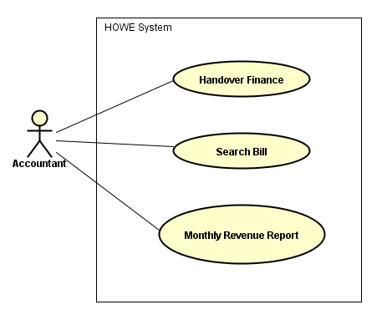
Figure 1.6 – Accountant Use Case Diagram

Use Case Specification

UC025 - Handover Finance
Use Case ID: |  | UC025 |  | Version: | 1.0
Use Case Name: |  | Handover Finance |  | Priority: | High
Created by: |  | QuyenTB |  | Date Created: | 29/05/2017
Actors: |  | Accounting
Description: |  | This function allows actor to handover finance to other actor
Trigger: |  | Click on “Finance Management” on the management page
Normal Flow
No | Actor Events |  |  | System Response
1 | Click on “Finance Management” then click on “Handover”
2 |  |  |  | Display handover finance form
3 | Enter information, click on “Add” button to add currency information
4 |  |  |  | Display details information into table at the below
5 | Click on “Next” button
6 |  |  |  | Display successfully message, display management page
Extension Flows
ET1 | At step 3 is repeated
ET2 | At step 5
No | Actor Events |  |  | System Response
5.1 | Click on “Cancel”
6.1 |  |  |  | Display management page
Exceptions:
EC1 | At step 3, required fields is not entered
No | Actor Events |  |  | System Response
3.1 |  |  |  | Display message prompts for data entry, focus on error objects
Business Rules: |  |  | N/A
Other Information: |  |  | N/A

UC026 - Search Bill
Use Case ID: |  | UC026 |  | Version: | 1.0
Use Case Name: |  | Search Bill |  | Priority: | High
Created by: |  | QuyenTB |  | Date Created: | 29/05/2017
Actors: |  | Accounting
Description: |  | This function allows actor search information of the bill
Trigger: |  | Click on “Finance Management” on the management page
Normal Flow
No | Actor Events |  |  | System Response
1 | Click on “Finance Management” then click on “Search Bill”
2 |  |  |  | Display searching bill form
3 | Enter searching information then click on “Search” button
4 |  |  |  | Display list of bills
5 | Select the bill
6 |  |  |  | Display detail information of the bill
Extension Flows
ET1 | At step 3 is repeated
ET2 | At step 3
No | Actor Events |  |  | System Response
3.1 | Do not input data
3.2 |  |  |  | Display all bills
Business Rules: |  |  | N/A
Other Information: |  |  | N/A

UC027 – Monthly Revenue Report
Use Case ID: |  | UC027 |  | Version: | 1.0
Use Case Name: |  | Monthly Revenue Report |  | Priority: | High
Created by: |  | QuyenTB |  | Date Created: | 29/05/2017
Actors: |  | Accounting
Description: |  | This function allows actor create monthly revenue report
Trigger: |  | Click on “Finance Management” on the management page
Normal Flow
No | Actor Events |  |  | System Response
1 | Click on “Finance Management” then click on “Turnover”
2 |  |  |  | Display turnover report form
3 | Enter information then click on “Next” button
4 |  |  |  | Display details information
5 | Click on “Print”
6 |  |  |  | Connect to printer, print information then display successfully message
Extension Flows
ET1 | At step 5
No | Actor Events |  |  | System Response
5.1 | Click on “Cancel” button
6.1 |  |  |  | Display management form
Exceptions:
EC1 | At step 3, required fields is not entered
No | Actor Events |  |  | System Response
3.1 |  |  |  | Display message prompts for data entry, focus on mandatory objects
Business Rules: |  |  | N/A
Other Information: |  |  | N/A

Non – Functional Requirement

Usability
- Interface should be beauty, simple, easy-to-use, and clear.
- The short, easy steps make it easy for actor to interact with the system immediately after training.
- Provide an introduction document to actor.

Supportability
All predefined values (price, dropdown values) must be easy to maintain, i.e. change/update and delete/add (where applicable). All the dropdown values can be upgraded in the period of one day without any shutdown. All the changed dropdown values before one specific time (the midnight ,…) can be displayed in the GUI after that time. Other should be done in the downtime.
As wordings are critical, all displayed text (error messages, labels, captions, information messages) must be easy to maintain, i.e. change/update and delete/add (where applicable). All the change for displayed text should be done in the downtime.
The website deployment and upgrade will be specified in the Installation Guide documents.

Design Constraints

Date/Time format
Default date format: DD/MM/YYYY (example: 29/05/2017)
Default time format: HH(24):MM (example: 22:07)

Number format
Decimal places only 1-digit (example 2.2)
Decimal places of ‘%’ is 1-digit (example: 23.4%)
Currency: !#,#.00(! is currency symbol, # is one or more digit)

Multi languages
This system will be implemented to support for the following languages:
- English
- Chinese
- Japanese
- Vietnamese

Interfaces
- User interfaces: system was developed to ensure stable operation on the following environments
  - Operator system: windows 8, 10
  - Browsers: Chrome
- Hardware interfaces: this system is linked to printer
- Software interfaces: none
- Communication interfaces: this system is linked to “agoda.com” website

Entity Relationship Diagram
<Provide the ERD Diagram for the system here. If your team uses a file or in-memory storage facility instead of a database, replace this section by ‘Data Structures’. Note, use only ERD or Data Structures>

Other material (if any)

Software Design Description (SDD – Report 04)

Design Overview

System Architectural Design

Choice of System Architecture

Discussion of Alternative Designs

Description of System Interface

Component Diagram

Detailed Description of Components

CRC Cards (Class-Responsibility-Collaborators)
4.4.1.n. Component-n
4.4.1.n.1. Class Diagram
4.4.2.n.2. Class Diagram Explanation
<Provide a brief explanation of the class diagram above. You do not need to explain “obvious” parts of your class diagram>
4.4.3.n.3. Algorithms of important methods in each class, specified in pseudo code or by Flow-Chart

Sequence Diagram

User Interface Design
4.6.1 Description of the User Interface
4.12.1.1 Screen Images
4.12.1.2 Objects and Actions

Database Design or Data Structures
<Provide the detailed database design for the system here. If your team uses a file or in-memory storage facility instead of database, remove this section; use the ‘Data Structures’ section. >

Other material (if any)

Report No.5: Software Test Documentation (STD)

5.1. Introduction
1.1 System Overview
1.2 Test Approach
5.2. Test Plan
2.1 Features to be tested
2.2 Features not to be tested
2.3 Testing Tools and Environment
5.3. Test Cases
3.n Case-n
3.n.1 Purpose
3.n.2 Inputs
3.n.3 Expected Outputs & Pass/Fail criteria
3.n.4 Test Procedure
5.5. Checklists
5.5.1. Checklist of Validation
<Put the checklist here. Describe how it is used and the resulted checklist>
5.5.2. Submission Checklist
<Put the checklist here. Describe how it is used and the resulted checklist>
5.5. Other material (if any) (including appendix A)
APPENDIX A. TEST LOGS
A.n Log for test n
A.n.1 Test Results
A.n.2 Incident Report

Report No.6: Software User’s Manual

6.1. Installation Guide
6.2. User’s Guide
6.3. Other [Optional]

